**FastFood Billing System-Indian Kitchen**

**Project Submitted To**

**SRM University, Andhra Pradesh**

**For the Partial fulfillment of the requirements to award the degree of**

**Bachelor Of Technology**

**In**

**Computer Science and Engineering**

**School of Engineering & Sciences.**

****

**Submitted By**

**K. Gautham (AP22110011145)**

**P.Roshini (AP22110011152)**

**M. Sravani (AP22110011151)**

**A. Mounika (AP22110011161)**

**Under the guidance Of**

**Prof. Awadhesh Dixit**

**SRM University, Andhra Pradesh**

**Neerukonda, Mangalagiri, Guntur, Andhra Pradesh - 522240**

**[April-2025]**

**CERTIFICATE**

**Date: 22-04-2025**

This is to certify that the work present in this Project entitled “**Fast Food Billing System**” has been carried out by **K. Gautham, P. Roshini, M. Sravani, A. Mounica** under my supervision. The work is genuine, original, and suitable for submission to the SRM University – AP for the award of Bachelor of Technology in School of Engineering and Sciences.

Supervisor (Signature)

**Dr. Awadhesh Dixit,**

Assistant Professor,

Department of CSE.

**ACKNOWLEDGEMENTS**

We would like to acknowledge the guidance and support provided by our mentor and advisor **Dr. Awadhesh Dixit**. Your wisdom and experience helped steer us in the right direction, and your feedback was instrumental in refining our ideas and approaches.

I extend my heartfelt thanks to my team members who collaborated tirelessly, sharing their expertise and insights, and working together cohesively towards our common goal. Each of you played a crucial role in shaping the project's outcome, and I am truly grateful for your contributions.

Furthermore, I am thankful for the resources and opportunities provided by our university, which enabled us to carry out this project successfully.

**ABSTRACT**

In today’s fast-paced digital landscape, an efficient and intuitive billing system is crucial for streamlining operations in the fast food industry. Our project focuses on building a modern, web-**based Fast Food Billing System** that simplifies order management, billing, and real-time data handling for both staff and customers.

This system is developed using a cutting-edge tech stack: **React with TypeScript** for building a robust front-end, **React Router** for smooth navigation, and **Tailwind CSS** along with shadcn/ui components for consistent and responsive UI styling. The back-end functionality is powered by **Supabase**, which provides seamless authentication, real-time database interactions . Additionally, we utilize React Query (@tanstack/react-query) for efficient data fetching and state management, while Lucide-react icons enhance the visual appeal and usability of the interface.

Our primary goal is to deliver a full-featured billing platform that accelerates service delivery, minimizes manual tasks, and ensures accuracy in order processing. By integrating essential features like order tracking, user authentication, and dynamic UI updates, this system brings speed, reliability, and ease-of-use to fast food businesses—all built on a scalable and open-source technology stack.

**COMPONENTS:**

1. **Front-end:**React with TypeScript, using React Router for routing.
2. **Back-end:**Supabase (a backend-as-a-service) for authentication, database, and API functionality.
3. **Styling:**Tailwind CSS with shadcn/ui components for UI elements and styling.
4. **State Management & Data Fetching:**React Query (@tanstack/react-query).
5. **Icons:**Lucide-react icon library.

**Table of Contents**

[**1. INTRODUCTION** 6](#_Toc196267184)

[**2. The Overall Description** 9](#_Toc196267185)

[**3. SYSTEM FEATURES** 12](#_Toc196267186)

[**4.DIAGRAMS** 14](#_Toc196267187)

[17](#_Toc196267188)

[**5.FRONTEND DESCRIPTION** 25](#_Toc196267189)

[**6.BACKEND DESCRIPTION** 26](#_Toc196267190)

[**7.RESULTS** 27](#_Toc196267191)

# **1. INTRODUCTION**

In today’s fast-paced digital era, managing customer orders and billing manually in fast food establishments can lead to delays, inaccuracies, and inefficiencies. With the advent of modern web technologies, the food industry is increasingly adopting digital solutions to streamline operations and improve customer service.

Our project introduces a **Fast Food Billing System** — a web-based application designed to simplify the order-taking and billing process. It facilitates quick and error-free billing, **real-time data handling**, and a user-friendly interface for staff and administrators. This system bridges the gap between traditional billing methods and modern digital practices, aiming to enhance speed, accuracy, and overall service quality.

**1.1 Purpose**

The primary objective of this project is to develop a reliable, responsive, and easy-to-use billing system tailored for fast food outlets. It **automates key operations** such as **order management, invoice generation**, and **user authentication**, significantly reducing manual work and increasing operational efficiency.

Key Objectives:

* To enable fast and accurate order processing and bill generation.
* To provide a clean and responsive UI for staff to manage orders easily.
* To ensure secure login and role-based access for employees.
* To reduce billing errors and improve customer satisfaction.
* To centralize and manage menu items, pricing, and availability efficiently.

This system benefits both employees and business owners by offering an organized and real-time solution to handle daily billing operations.

**1.2 Scope**

The scope of this project includes the development of a modern, web-based Fast Food Billing System using React with TypeScript, Supabase, and Tailwind CSS, with features such as:

* Employee Login and Role-based Access
* Menu Management (add/update/delete items)
* Order Placement and Tracking
* Real-time Invoice Generation
* Database Storage for Orders and Employees
* Responsive UI using shadcn/ui and Lucide-react icons
* Efficient data fetching and state management with React Query

This project is designed to be scalable and can be enhanced in the future with features like sales analytics, inventory tracking, customer-facing ordering interfaces, and mobile support. Development will be carried out over a planned timeline with dedicated phases for design, implementation, testing, and deployment.

**1.3 DEFINITIONS, ACRONYMS, AND ABBREVIATIONS.**

|  |  |  |
| --- | --- | --- |
| | **Term** | **Definition** | | --- | --- | |
| |  |  | | --- | --- | | Process: | A function or operation that transforms input data into meaningful output. | |
| |  |  | | --- | --- | | Data Flow | :The movement of data between external entities, processes, and data stores. | |
| |  |  | | --- | --- | | Data Store: | A storage location where data is held for processing or future use. | |
| |  |  | | --- | --- | | External Entity: | Any person, system, or organization outside the billing system that interacts with it. | |
| |  |  | | --- | --- | | Order Database: | Stores information related to customer orders, billing amounts, and timestamps. | |
| |  |  | | --- | --- | | Employee Database : | Holds employee records, access roles, and login credentials. | |
| |  |  | | --- | --- | | Menu Database | : Contains menu items along with their prices, categories, and availability. | |
| |  |  | | --- | --- | | Invoice : | A generated document summarizing the order details and final bill. | |
| |  |  | | --- | --- | | Front-End : | The user-facing side of the application, built using React and TypeScript. | |
| |  |  | | --- | --- | | Back-End | : Handles data processing, authentication, and storage using Supabase. | |
| |  |  | | --- | --- | | Tailwind : CSS | A utility-first CSS framework used for designing responsive UI layouts. | |
| |  |  | | --- | --- | | shadcn/ui | : A set of styled, accessible React components used for the UI. | |
| |  |  | | --- | --- | | React Query | : A data-fetching and caching library used to manage server state in React apps. | |
| |  |  | | --- | --- | | Lucide-react : | A modern, customizable icon library used within the UI. | |
| |  |  | | --- | --- | | Authentication: | The process of verifying user identity to allow secure system access. | |
| |  |  | | --- | --- | | Billing System | : The system component that calculates the total cost and generates invoices. | |
| |  |  | | --- | --- | | React Router | : A library used for handling navigation and routing in a React application. | |

**1.4 References**

The development and conceptualization of the Fast Food Billing System have been guided by various resources that provide insights into billing systems, database management, and user interface design:

1. **Scribd - Fast Food Billing System**: A detailed document proposing a self-service billing system to address inefficiencies in manual systems. ​[Scribd](https://www.scribd.com/document/604089857/Fast-food-billing-system?utm_source=chatgpt.com)
2. **Bdtask Blog - What is Restaurant Billing System?**: An article explaining the integration of POS software in restaurant billing systems and their key features. ​[www.slideshare.net+4https://www.bdtask.com+4www.slideshare.net+4](https://www.bdtask.com/blog/what-is-restaurant-billing-system?utm_source=chatgpt.com)
3. **GitHub - Fast-Food-Billing-System**: A project utilizing C programming to develop a fast food billing system, providing practical coding insights. ​[GitHub](https://github.com/ericgoh09/Fast-Food-Billing-System?utm_source=chatgpt.com)
4. **Studocu - Fast Food Billing System**: A document discussing the challenges of traditional billing systems and the advantages of modern solutions. ​[Studocu](https://www.studocu.com/in/document/university-of-mumbai/bsc-computer-science/fast-food-billing-system/43768781?utm_source=chatgpt.com" \t "_blank)
5. **Foodiv - 10 Benefits of Restaurant Billing System**: An article highlighting the benefits of implementing billing software in restaurants for efficient service delivery. ​[Restaurant365+2Foodiv+2accountantlalaji.com+2](https://www.foodiv.com/benefits-of-restaurant-billing-system/?utm_source=chatgpt.com)
6. **W3Schools - PostgreSQL Tutorial**: A comprehensive guide to PostgreSQL, aiding in the database management aspect of the system.​
7. **MDN Web Docs - TypeScript**: Documentation and tutorials on TypeScript, supporting the development of the frontend interface.​

**1.5 Overview**

* **Section 1.0**: Introduces the Fast Food Billing System, outlining its purpose to streamline ordering and billing processes in fast-food outlets. It also defines key terms and components used throughout the system.​
* **Section 2.0**: Describes the overall functionalities of the system, detailing user roles such as Cashiers, Managers, and Admins, along with software and hardware constraints.​
* **Section 3.0**: Details the functional and non-functional requirements, including design specifications necessary for developing the system, such as user interfaces, hardware/software interfaces, and communication protocols.​
* **Section 4.0**: Presents the system features, elaborating on modules like Menu Management, Order Placement and Billing, and their respective functional requirements.​
* **Section 5.0**: Outlines the performance, safety, and security requirements, ensuring the system's reliability and data integrity. It also discusses software quality attributes and documentation practices.​

# **2. The Overall Description**

**2.1 Product Perspective**

**Functional Units and Components:**

* **Menu Management Module**: Handles addition, updating, and deletion of food items.
* **Order Processing System**: Manages item selection, quantity updates, and calculates totals including taxes.
* **Billing & Receipt Generation**: Generates real-time receipts for orders.
* **User Management Module**: Allows admins/cashiers to log in and manage their sessions.
* **Reports & Analytics Module**: Provides insights into daily sales, popular items, and revenue summaries.
* **SQL Database (PostgreSQL)**: For storing food items, transactions, and user records.

**Accessibility and Self-Service Features:**

* Accessible via web browsers, supporting on-premise ordering at counters.
* Optional extension for self-service kiosks or mobile ordering interface.
* Real-time order updates for both staff and customers.

**Hardware and Software Specifications:**

* **Hardware**: Standard POS terminal or PC (minimum 2 GB RAM), thermal printer for receipts.
* **Software**: Web server stack ,PostgreSQL, modern browser.

**Communication:**

* Communicates via HTTP/HTTPS protocols.
* Backend interactions handled through REST APIs connected to the database.

**Capacity and Scalability:**

* Designed to handle hundreds of daily transactions with concurrent user sessions.
* Can be expanded to support multi-branch operations and integration with external accounting systems.

**User Experience (UX):**

* Clean and responsive UI for fast interactions during rush hours.
* Intuitive navigation for order customization and receipt printing.
* Role-based access for cashier, manager, and admin operations.

**2.2 Product Functions**

Key functionalities of the Fast Food Billing System include:

* **Food Item Management**: Admins can add, update, and delete menu items with fields such as name, price, category, and availability status.
* **Order Placement**: Users (cashiers) select food items, apply quantities, and generate order totals in real-time.
* **Billing System**: The system auto-calculates subtotal, taxes, and total price, and generates a printable bill.
* **User Authentication**: Session-based login system for staff and admins.
* **Sales Reports**: Admins can generate daily/weekly/monthly sales reports.
* **Security Features**: Secure login, input validation, and access restrictions based on user role.
* **Database Backup**: Regular backups of transactions and menu data to ensure reliability and recovery.

**2.3 User Characteristics**

**General Users-Cashiers**

* Interface designed for ease of use, with simple order flow and help tooltips.
* Limited system access to avoid accidental data manipulation.
* Advanced order editing and quick-access buttons for popular combos.
* Access to previous order history, reprint bills.

**Administrative Users-Managers/Admins**

* Full access to all system modules, including price updates, item deactivation, and reports.
* Can track cashier performance and review transactions by date or staff.

**System Developers/IT Support**

* Access to configuration files, database management, and logs.
* Responsible for performing updates, bug fixes, and ensuring data integrity.

**Cross-User Considerations**

* Role-based permissions enforced at all levels.
* Accessibility for staff with limited technical knowledge.
* Scalable for a growing number of staff or outlets.

**2.4 Constraints**

**Technical Constraints**

* Each order must be processed sequentially to prevent billing errors.
* Concurrent session restrictions may apply to avoid fraud (e.g., one cashier per terminal).
* Data validation for price, quantity, and item IDs is strictly enforced.
* Requires stable server and internet for real-time reporting features.
* Limited to supported formats for data export (e.g., CSV, PDF for reports).

**Operational Constraints**

* Staff can only access features assigned to their role.
* Receipt printers must support required formats and fonts.
* POS systems must meet minimum specs for smooth operation (4 GB RAM, SSD recommended).

**UX Constraints**

* Must comply with accessibility best practices (contrast ratios, keyboard navigation).
* System needs to respond quickly under load (peak lunch/dinner hours).
* Include multilingual support if deployed in diverse regions.

**Regulatory and Compliance Constraints**

* Must comply with local tax and invoice laws.
* Secure handling of staff credentials and customer feedback.
* Optionally, integration with GST or local tax APIs (e.g., for India or EU VAT).

**2.5 Assumptions and Dependencies**

**Assumptions**

* Staff are trained to use basic web applications.
* A stable internet or intranet connection exists between client terminals and server.
* Server environment is maintained by IT staff and regularly updated.
* Admin users are responsible for maintaining accurate menu data.

**Dependencies**

* Application depends on active server, correctly configured database, and browser compatibility.
* Functional operations require backend scripts to calculate totals, taxes, and generate bills.
* PDF generation or email receipt features may require third-party libraries.
* Changes to menu or logic should undergo testing to avoid production bugs.

# **3. SYSTEM FEATURES**

The Fast Food Billing System is a web-based application designed to simplify and streamline order processing, menu management, and administrative reporting within a fast food environment. The system provides role-based interfaces and tools for cashiers, managers, and administrators to manage daily operations efficiently.

**3.1 Common Interface Features**

These features are available to all users across different roles:

1. **Login Now Button**

* **Functionality:** Redirects registered users to a secure login page.
* **Location:** Top-right corner of all pages.
* **Purpose:** Ensures authorized access based on role (cashier, manager, admin).

1. **Register Now Button**

* **Functionality:** Opens the registration page for new users.
* **Purpose:** Allows creation of new accounts . All new accounts are Cashiers only. (typically controlled by admin).

1. **Navigation Menu**
   * **Tabs may vary by user role** but commonly include:
     + **Dashboard:** Role-specific overview and key actions.
     + **Orders:** View, manage, and track order status.
     + **Settings / Profile:** Manage personal info or system settings.

**3.2 Cashier Features**

Cashiers are responsible for managing the order-taking process and updating order statuses in real-time.

1. **Dashboard Tab**
   * **Purpose:** Displays real-time summary of placed and served orders.
2. **New Order Tab**
   * **Functionality:**
     + View available menu items.
     + Add items to an order.
     + Specify quantity and customer name.
     + Auto-generate total amount and taxes.
     + Generate and print receipts dynamically.
   * **Goal:** Enable quick, error-free customer order processing.
3. **Orders Tab**
   * **Functionality:**
     + View current and past orders.
     + Update order status i.e. mark as *Served*.
     + Track pending and active orders for kitchen coordination.

**3.3 Manager Features**

Managers oversee daily operations, including menu updates and real-time order tracking.

1. **Dashboard Tab**
   * **Overview:** Current number of active orders and sales snapshot.
2. **Menu Management Tab**
   * **CRUD Operations:**
     + Create, update, or delete menu items.
     + Modify item price, availability, and description.
   * **Inventory Control:** Keep menu relevant and updated based on stock or promotions.
3. **Orders Tab**
   * **Functionality:**
     + View all orders by stage: Pending, In Progress, Completed, Cancelled.
     + Update the progress status of any order.
     + **Note:** Cancelled orders are locked and cannot be modified again.

**3.4 Admin Features**

Admins have full control over the system, including users, revenue, reports, and global settings.

1. **Dashboard Tab**
   * **Analytics View:**
     + Total revenue generated.
     + Top 5 recent/high-value orders.
     + Best-selling menu items.
     + Real-time system statistics.
2. **Orders Tab**
   * **Purpose:** Monitor and manage all orders across cashiers and branches.
   * **Functionality:** Edit order progress, filter by status, and override where needed.
3. **User Management Tab**
   * **Functionality:**
     + View all registered users.
     + Assign or change user roles (e.g., promote cashier to manager).
     + Manage user access and reset credentials.
4. **Reports Tab**
   * **Auto-Generated Reports:**
     + View revenue and order trends by day, hour, or custom date range.
     + Downloadable reports in **CSV format** for offline review.
   * **Insight:** Helps in planning staff shifts, promotions, or pricing strategies.
5. **Settings Tab**
   * **Purpose:** Configure application-level settings.
   * **Features:**
     + Change project name or branding.
     + Toggle between dark/light mode or other UI settings.

# **4.DIAGRAMS**

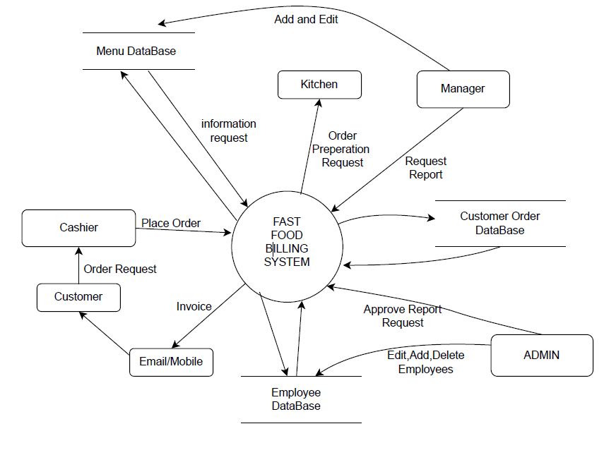

Figure 1: Contexct Free Diagram

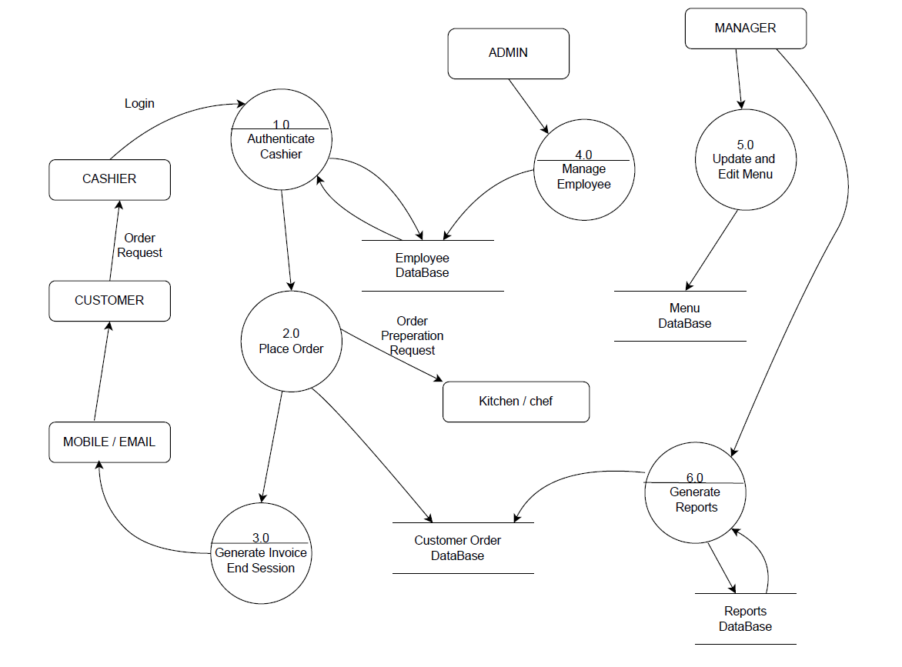

Figure 2: DFD0 , Consisting High level processes

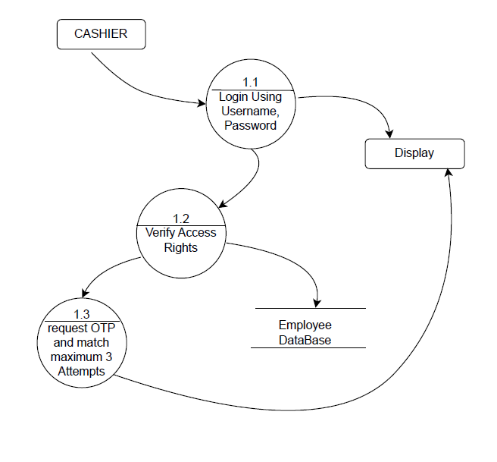

Figure 3: Authenticate Cashier

### 

Figure 4 : Add to cart

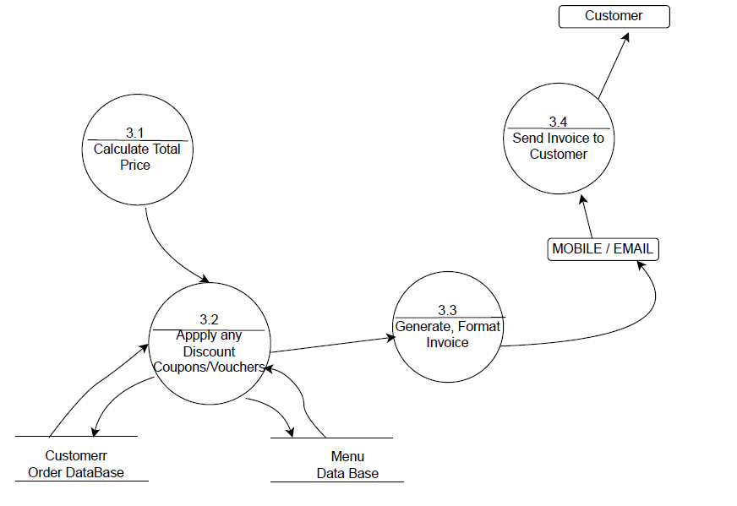

Figure 5: Place order and Generate Invoice

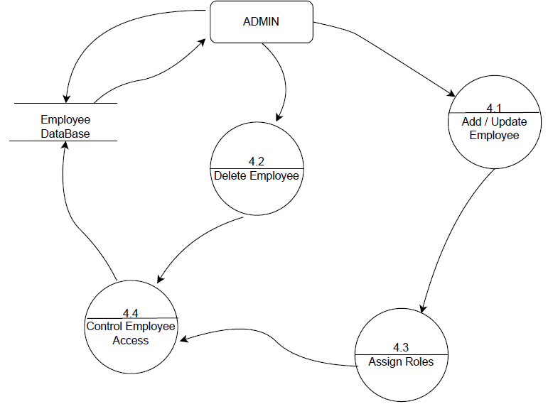

Figure 6: Manage employees

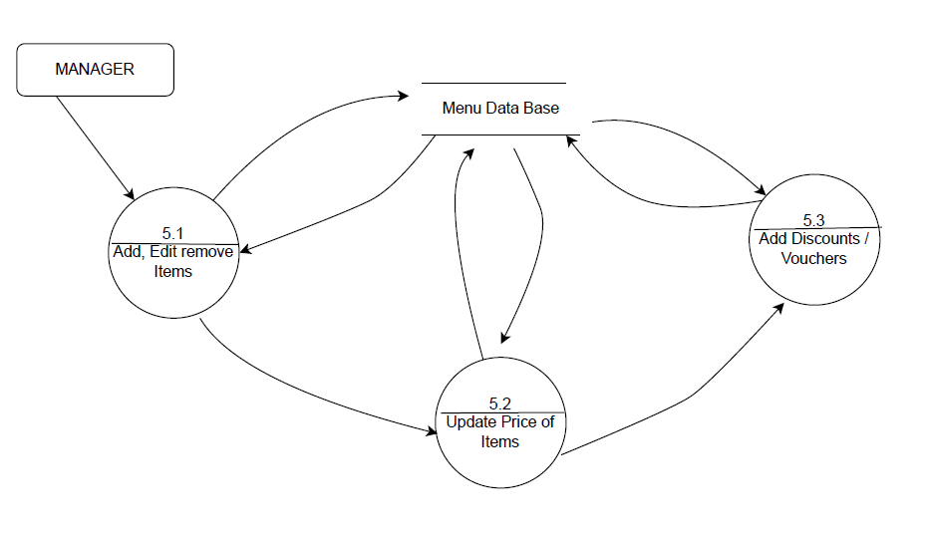

Figure 7: Edit Menu Items

**Data Base Schema**

**1. profiles**

* Attributes:
  + id (Primary Key, UUID)
  + email (text)
  + role (text)
  + created\_at (timestamptz)
* Relationships:
  + Related to orders.created\_by (auth.users.id)

**2. orders**

* Attributes:
  + id (Primary Key, UUID)
  + customer\_name (text)
  + customer\_contact (text)
  + total\_amount (numeric)
  + status (text)
  + created\_by (Foreign Key → profiles.id)
  + created\_at (timestamptz)
  + updated\_at (timestamptz)
* Relationships:
  + Referenced by order\_items.order\_id

**3. order\_items**

* Attributes:
  + id (Primary Key, UUID)
  + order\_id (Foreign Key → orders.id)
  + menu\_item\_id (Foreign Key → menu\_items.id)
  + name (text)
  + price (numeric)
  + quantity (int)
  + subtotal (numeric)
  + created\_at (timestamptz)
* Relationships:
  + References menu\_items
  + Belongs to orders

**4. menu\_items**

* Attributes:
  + id (Primary Key, UUID)
  + name (text)
  + description (text)
  + price (numeric)
  + category (text)
  + image\_url (text)
  + created\_at (timestamptz)
  + updated\_at (timestamptz)
* Relationships:
  + Referenced in order\_items

**ER DIAGRAM :**

**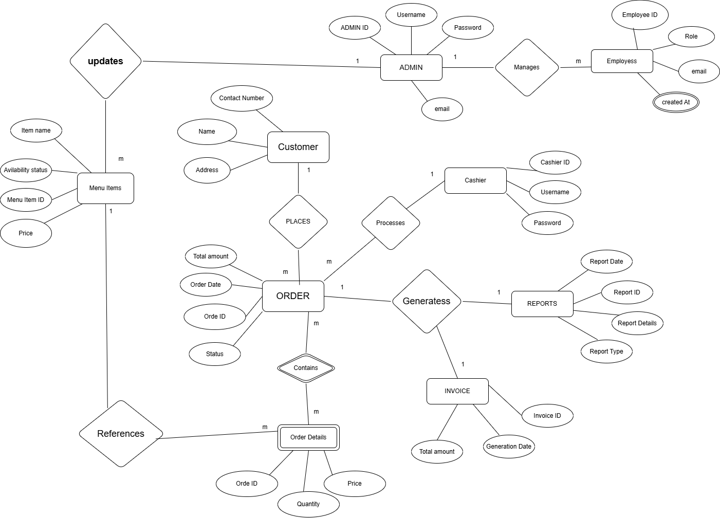**

**RELATIONAL TABLES :**   
**1. profiles**

|  |  |  |  |
| --- | --- | --- | --- |
| ID | email | role | Created at |
| Primary Key |  |  |  |

**2. Orders**

|  |  |  |  |  |  |  |  |
| --- | --- | --- | --- | --- | --- | --- | --- |
| ID | Customer Name | Customer Contact | Total Amouint | Status | Created At | Created At(FK) | Time Stamp |
| PrimaryKey |  |  |  |  | Foreign Key |  |  |

**3. Order\_items**

|  |  |  |  |  |  |  |  |
| --- | --- | --- | --- | --- | --- | --- | --- |
| ID | Order ID | Menu ItemID | Name | price | Quantity | Subtotal | Created At |
| Primary Key | Foreign Key | Foreign Key |  |  |  |  |  |

**4.**

|  |  |  |  |  |  |  |  |
| --- | --- | --- | --- | --- | --- | --- | --- |
| ID | Name | Description | price | Category | Image\_url | Updated At | Created At |
| Primary Key |  |  |  |  |  |  |  |

**SQL CODE :**

**-- 1. Profiles Table**

CREATE TABLE profiles (

id SERIAL PRIMARY KEY,

email VARCHAR(255) UNIQUE NOT NULL,

role VARCHAR(50) NOT NULL,

created\_at TIMESTAMP DEFAULT CURRENT\_TIMESTAMP

);

**-- 2. Orders Table**

CREATE TABLE orders (

id SERIAL PRIMARY KEY,

customer\_name VARCHAR(255) NOT NULL,

customer\_contact VARCHAR(20) NOT NULL,

total\_amount NUMERIC(10, 2) NOT NULL,

status VARCHAR(50) NOT NULL,

created\_at TIMESTAMP DEFAULT CURRENT\_TIMESTAMP,

created\_by INTEGER, -- references profiles.id

time\_stamp TIMESTAMP DEFAULT CURRENT\_TIMESTAMP,

CONSTRAINT fk\_created\_by FOREIGN KEY (created\_by) REFERENCES profiles(id)

);

**-- 3. Menu Items Table**

CREATE TABLE menu\_items (

id SERIAL PRIMARY KEY,

name VARCHAR(255) NOT NULL,

description TEXT,

price NUMERIC(10, 2) NOT NULL,

category VARCHAR(100),

image\_url TEXT,

updated\_at TIMESTAMP DEFAULT CURRENT\_TIMESTAMP,

created\_at TIMESTAMP DEFAULT CURRENT\_TIMESTAMP

);

**-- 4. Order Items Table**

CREATE TABLE order\_items (

id SERIAL PRIMARY KEY,

order\_id INTEGER NOT NULL,

menu\_item\_id INTEGER NOT NULL,

name VARCHAR(255) NOT NULL,

price NUMERIC(10, 2) NOT NULL,

quantity INTEGER NOT NULL,

subtotal NUMERIC(10, 2) GENERATED ALWAYS AS (price \* quantity) STORED,

created\_at TIMESTAMP DEFAULT CURRENT\_TIMESTAMP,

CONSTRAINT fk\_order FOREIGN KEY (order\_id) REFERENCES orders(id),

CONSTRAINT fk\_menu\_item FOREIGN KEY (menu\_item\_id) REFERENCES menu\_items(id)

);

**-- Process relationship: Cashier processes Orders**

ALTER TABLE Orders ADD CashierID INT;

ALTER TABLE Orders ADD FOREIGN KEY (CashierID) REFERENCES Cashier(CashierID);

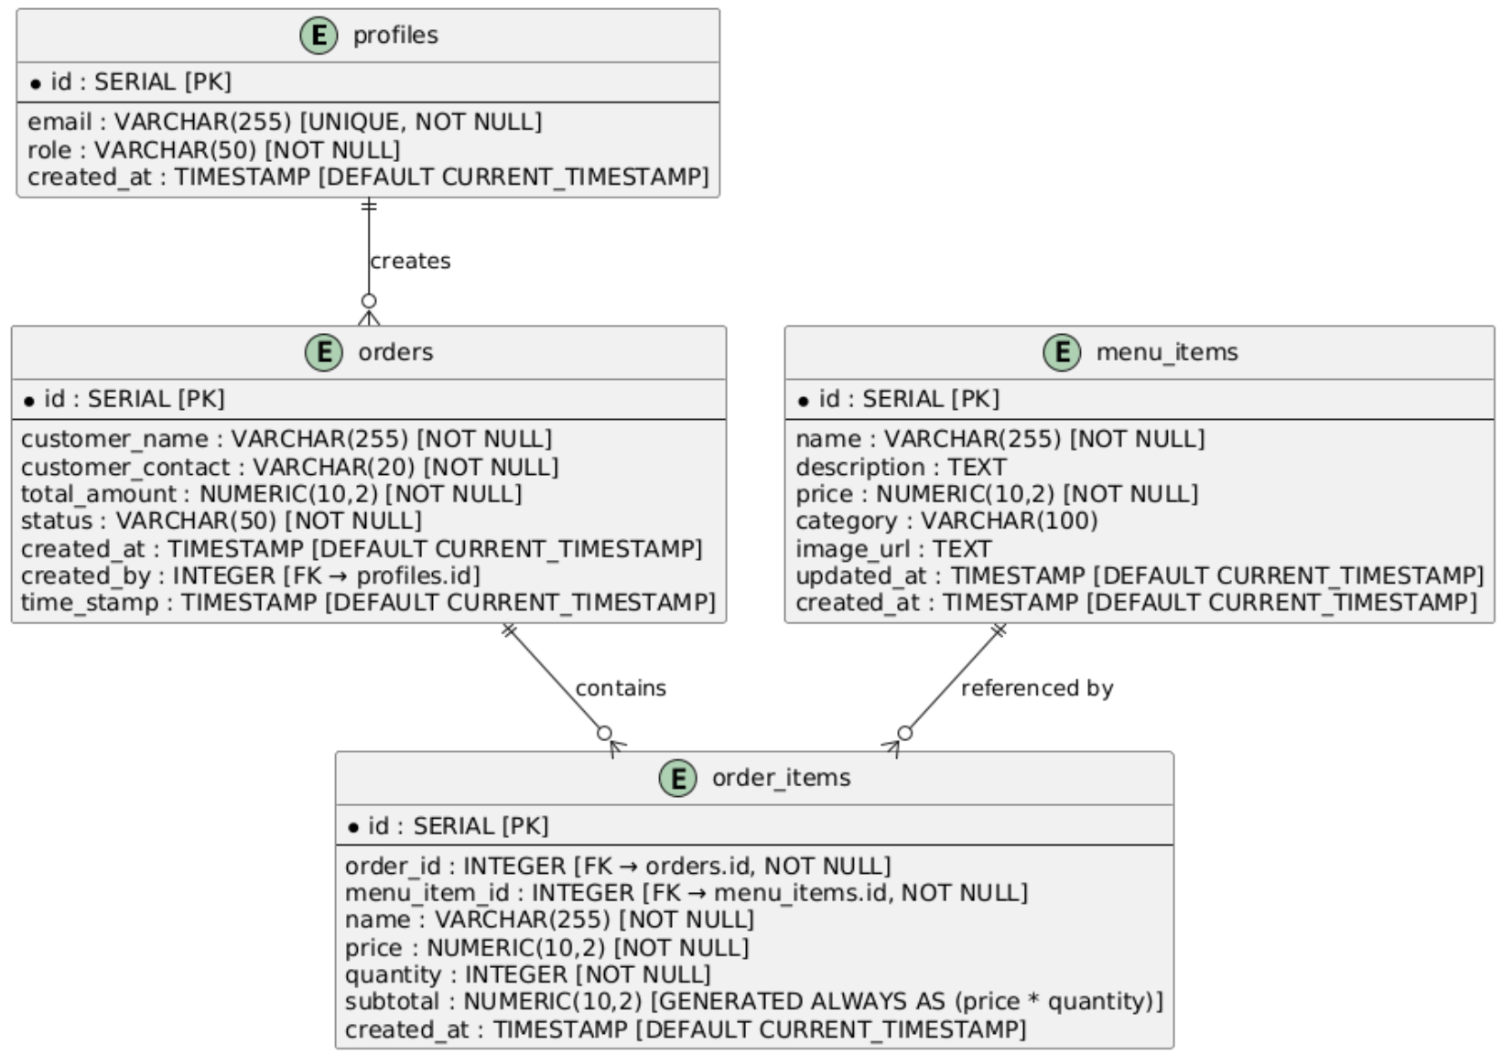

Figure 8 : Class Diagram

**Object Diagram**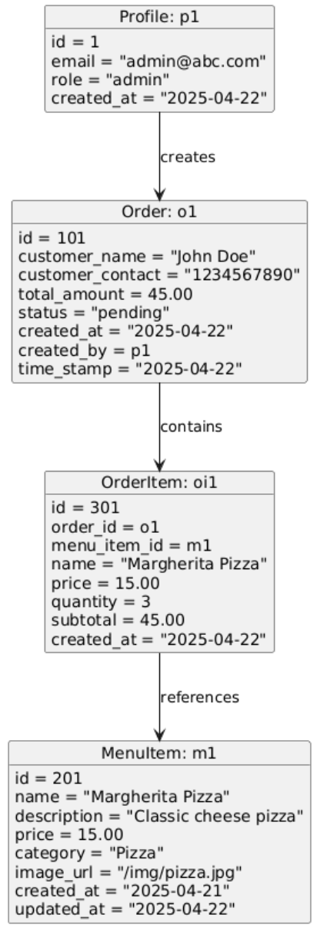

Figure 9: Object Diagram

**Profile: p1**

* ID: 1
* Email: admin@abc.com
* Role: admin
* Created At: 2025-04-22

**Customer: john**

* Name: John Doe
* Contact: 1234567890
* Order Reference: o1

**Order: o1**

* ID: 101
* Customer Name: John Doe
* Customer Contact: 1234567890
* Total Amount: 45.00
* Status: pending
* Created At: 2025-04-22
* Created By: p1
* Timestamp: 2025-04-22

**OrderItem: oi1**

* ID: 301
* Order ID: o1
* Menu Item ID: m1
* Name: Margherita Pizza
* Price: 15.00
* Quantity: 3
* Subtotal: 45.00
* Created At: 2025-04-22

**MenuItem: m1**

* ID: 201
* Name: Margherita Pizza
* Description: Classic cheese pizza
* Price: 15.00
* Category: Pizza
* Image URL: /img/pizza.jpg
* Created At: 2025-04-21

# **5.FRONTEND DESCRIPTION**

**Technology Stack:**

* **React (with TypeScript)** – Component-based UI with type safety
* **Vite** – Fast development and optimized builds
* **Tailwind CSS / CSS Modules** – For utility-first, responsive styling
* **JavaScript/TypeScript** – For logic, state handling, and integration
* **React Router DOM** – SPA routing between pages and dashboards
* **Deployed on Vercel** – For seamless, scalable deployment.

**User Interface Overview:**

**Role-Based UI:**

Each role (Cashier, Manager, Admin) has access to specific dashboards with React components conditionally rendered based on user role (stored via Supabase Auth).

**Cashier Dashboard:**

* Tabs: Dashboard, New Order, Orders
* **New Order:** View menu, add items, auto-generate receipt (with customer name and details), update order status
* **Real-time Status Updates:** React state and Supabase real-time subscriptions update UI instantly when orders are served or completed.

**Manager Dashboard:**

* Tabs: Dashboard, Menu Management, Orders
* **CRUD Functionality:** Add, update, delete menu items using interactive modals/forms
* **Order Monitoring:** Track order lifecycle (Pending → In Progress → Completed or Cancelled)
* **Immutable Cancelled Orders:** Once marked as "cancelled," orders become read-only

**Admin Dashboard:**

* Tabs: Dashboard, Orders, User Management, Reports, Settings
* **Analytics View:** Displays total revenue, top 5 orders, top-selling items
* **Reports:** Filter by date/hour, export as .csv
* **User Management:** Role switching and user detail updates
* **Settings:** Change project name, theme (dark/light), etc.

**UX & Frontend Interactivity:**

* **Authentication:** Handled by Supabase Auth with email/password and session tokens
* **Forms:** Type-safe forms using libraries like react-hook-form or Formik
* **State Management:** React Context, useReducer, or Zustand (if used)
* **Responsive Design:** Tailored for both POS devices and desktops
* **Animations & Modals:** Smooth transitions via Framer Motion or Headless UI

# **6.BACKEND DESCRIPTION**

**Technology Stack:**

* **Supabase** – Backend-as-a-Service (based on PostgreSQL)
* **PostgreSQL** – Relational database with advanced queries
* **Supabase Auth** – User management and secure auth
* **Edge Functions / RLS (Row-Level Security)** – Fine-grained access control

**Database Architecture (via Supabase/PostgreSQL):**

**Tables:**

* users: name, email, role (admin, manager, cashier), created\_at
* menu\_items: id, name, price, category, image\_url, is\_active
* orders: id, customer\_name, status, created\_by (cashier), total\_price, created\_at
* order\_items: order\_id, item\_id, quantity, subtotal
* payments: order\_id, method, payment\_status, paid\_at (**future enhancement)**
* reports: auto-generated via scheduled SQL queries or Supabase Functions

**Authentication & Authorization:**

* Supabase Auth handles login/signup with secure JWT tokens
* Role-based access via RLS policies ensures users can only access allowed data

**Order Processing Logic:**

* Orders are created via frontend and inserted into orders and order\_items tables
* Real-time updates via Supabase subscriptions push status changes to UI
* Cashiers update status (e.g., “In Progress”, “Completed”), and receipts are rendered client-side

**Admin Reporting and Data Export:**

* Dynamic SQL views or Supabase Functions used to generate daily/hourly reports
* Export to CSV using frontend logic or Supabase Edge Functions
* Insights: Total revenue, top-selling items, performance by cashier/manager

**Future Enhancements:**

* **Payment Integration:** Stripe or Razorpay for real-time payments and receipt tracking
* **Client Consultation Module:** Booking consultations with experts, integrated calendar/scheduler
* **Progressive Web App (PWA):** For better mobile usability and offline support
* **Inventory Management:** Track stock levels for ingredients/menu items
* **AI-Driven Suggestions:** Recommend top-selling combos or upsells

# **7.RESULTS**

Cashier Landing Page : 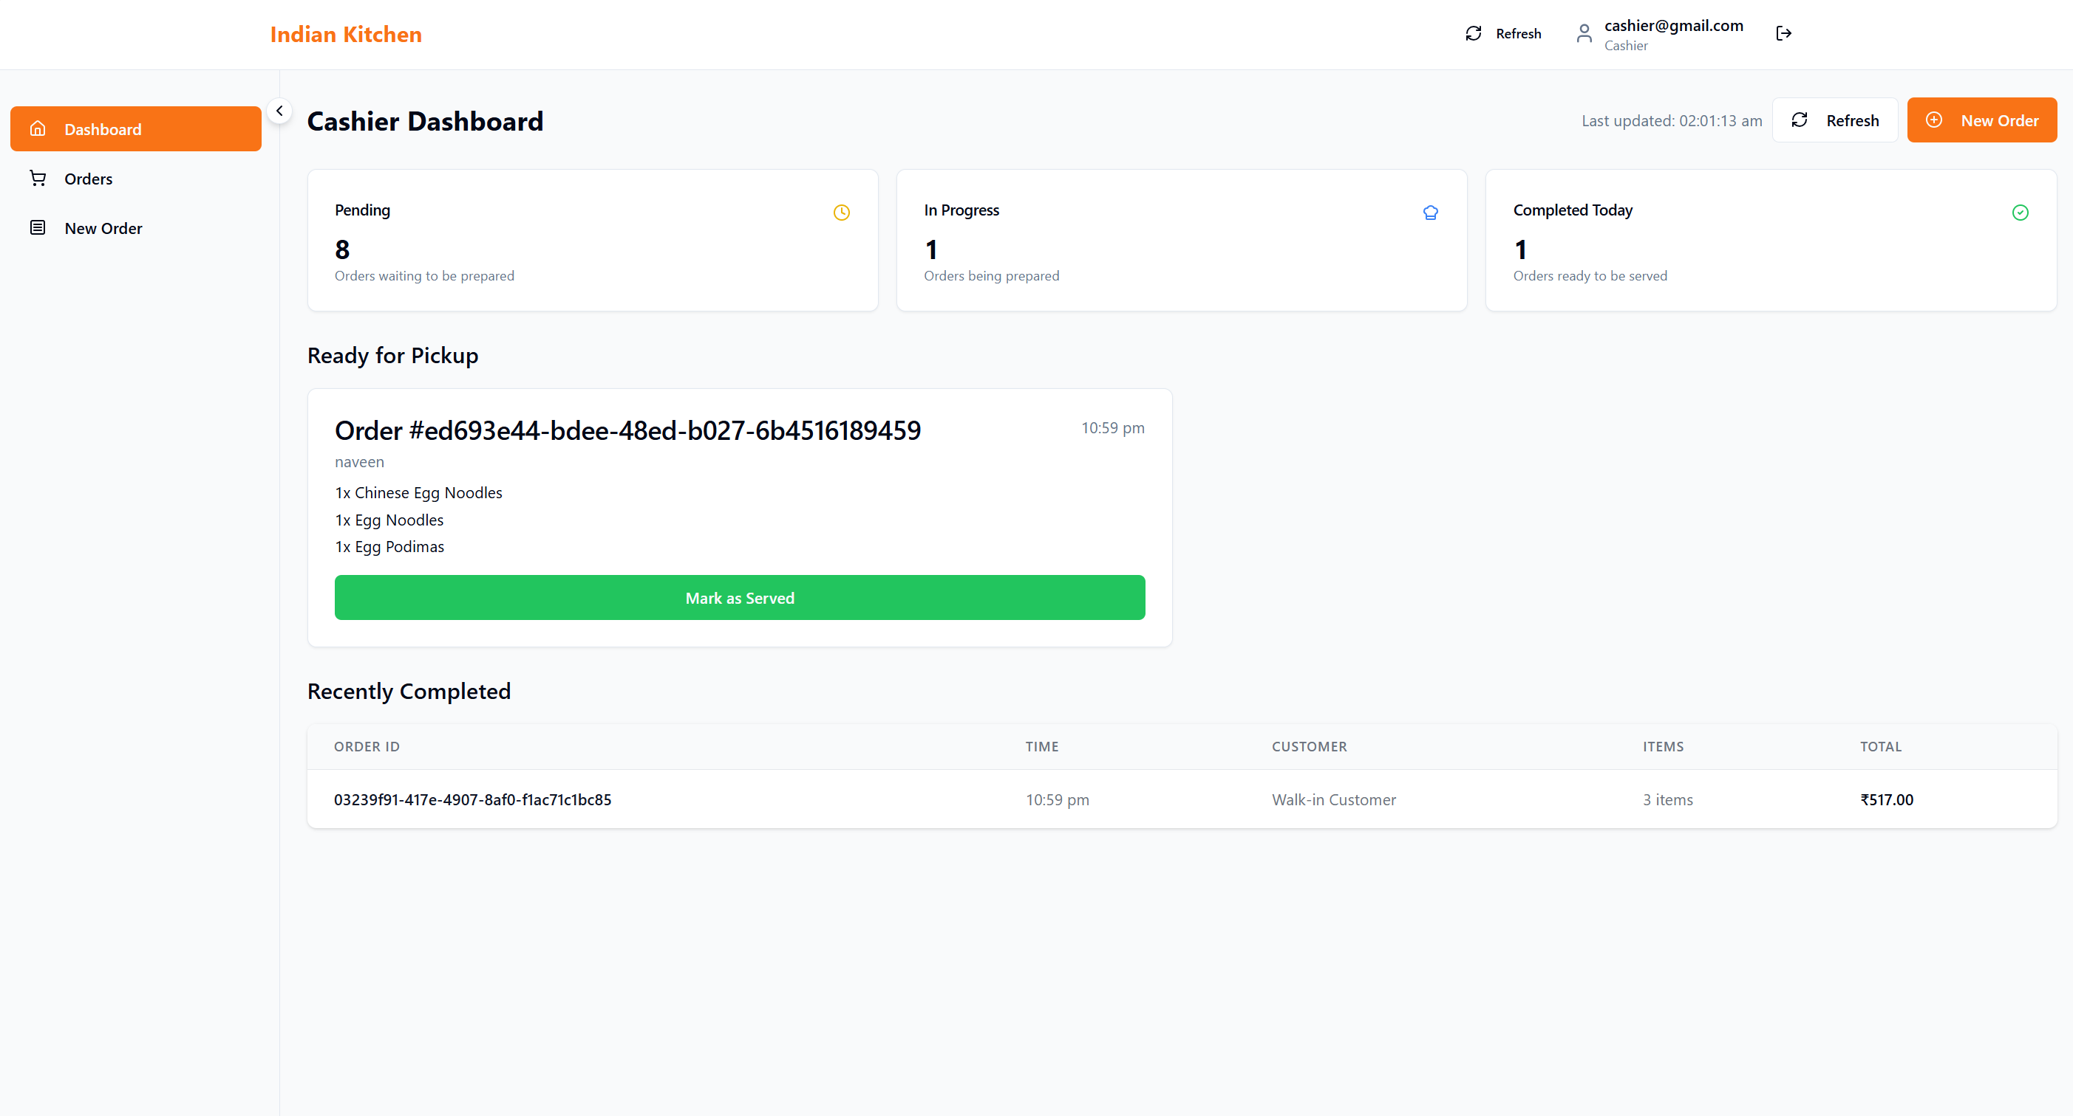

Cashier Orders Tab : 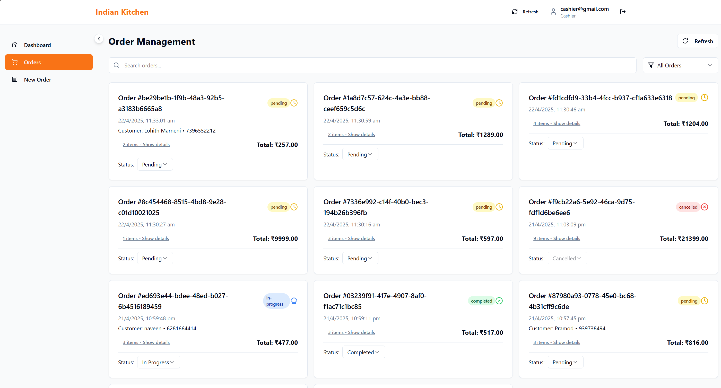

Cashier New Order Page :

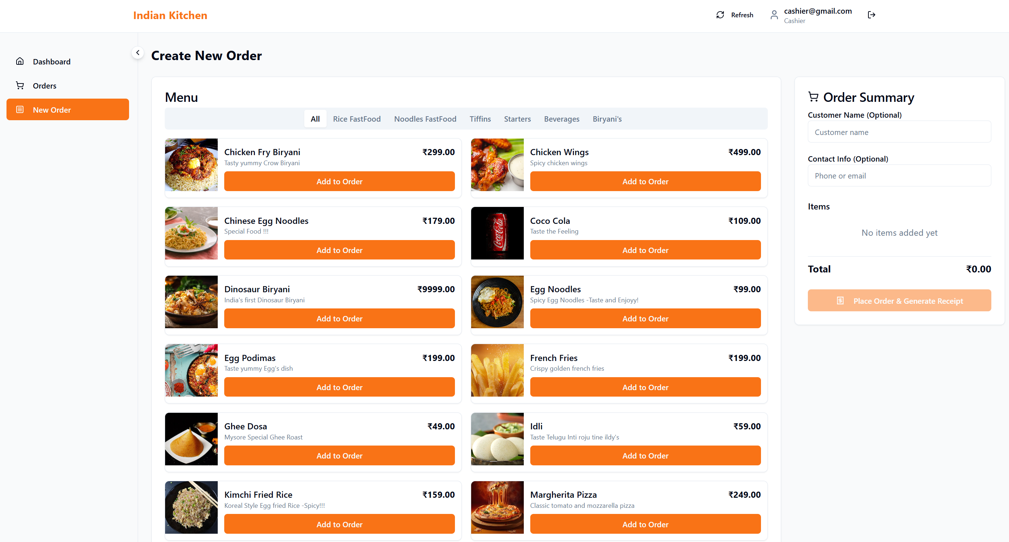

Print Bill :

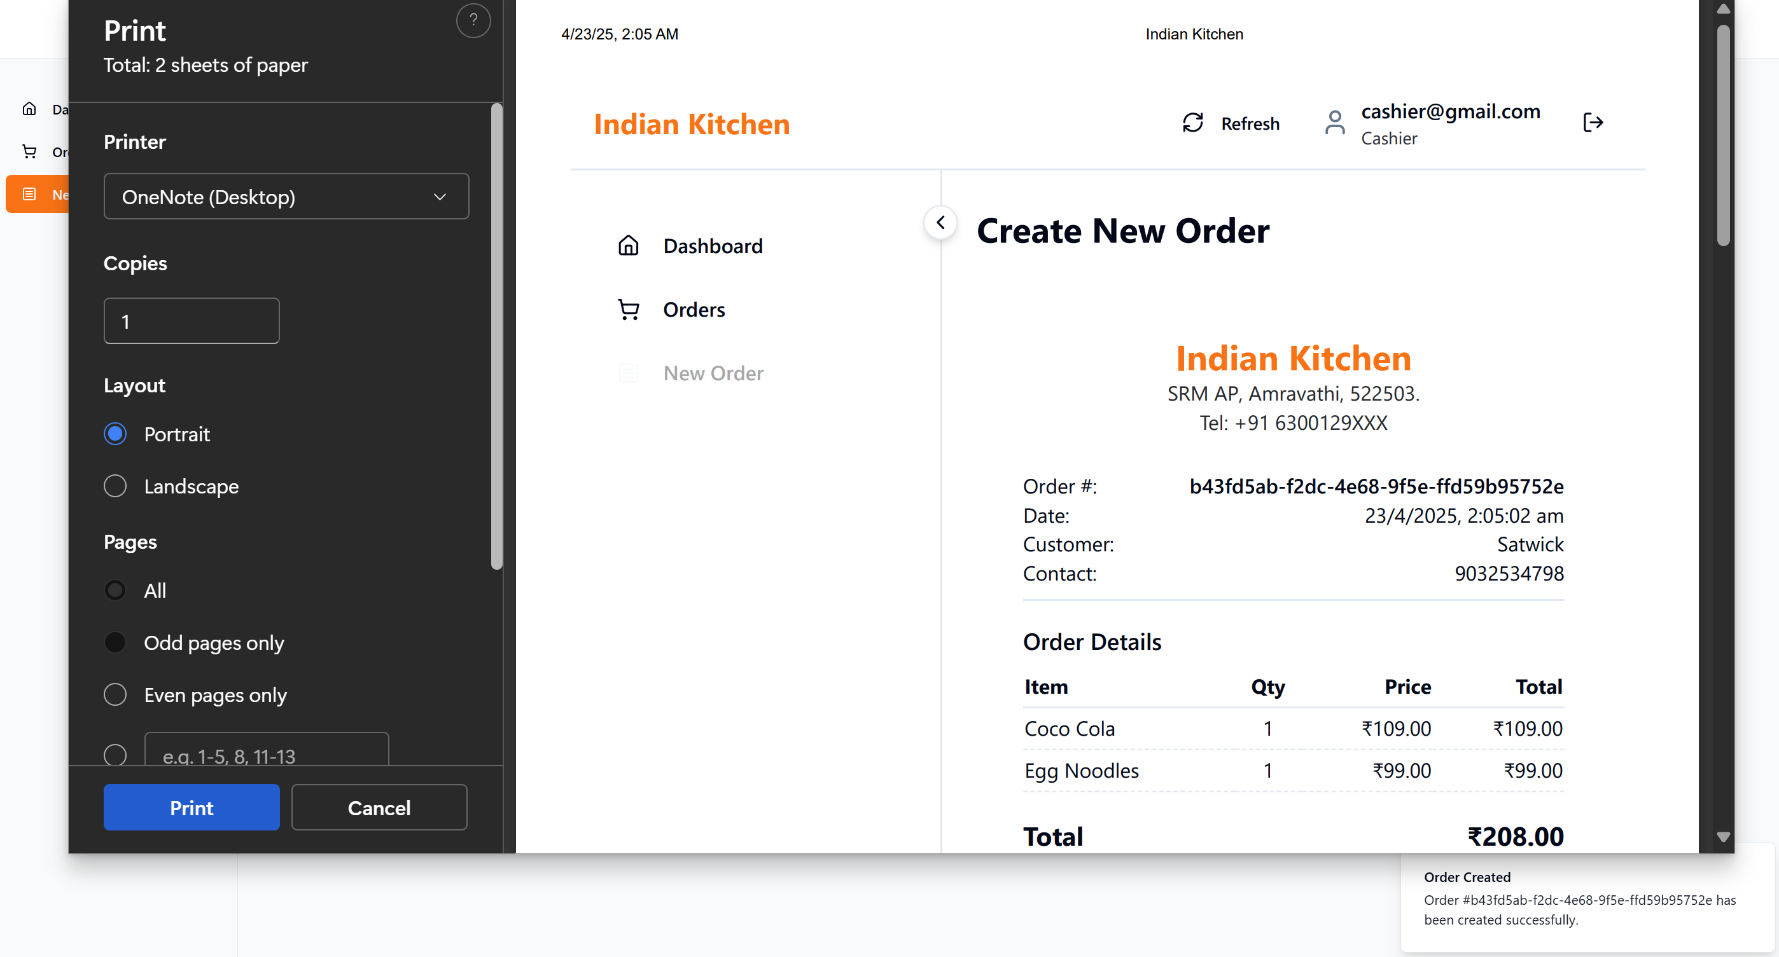

Manager Dash Board : 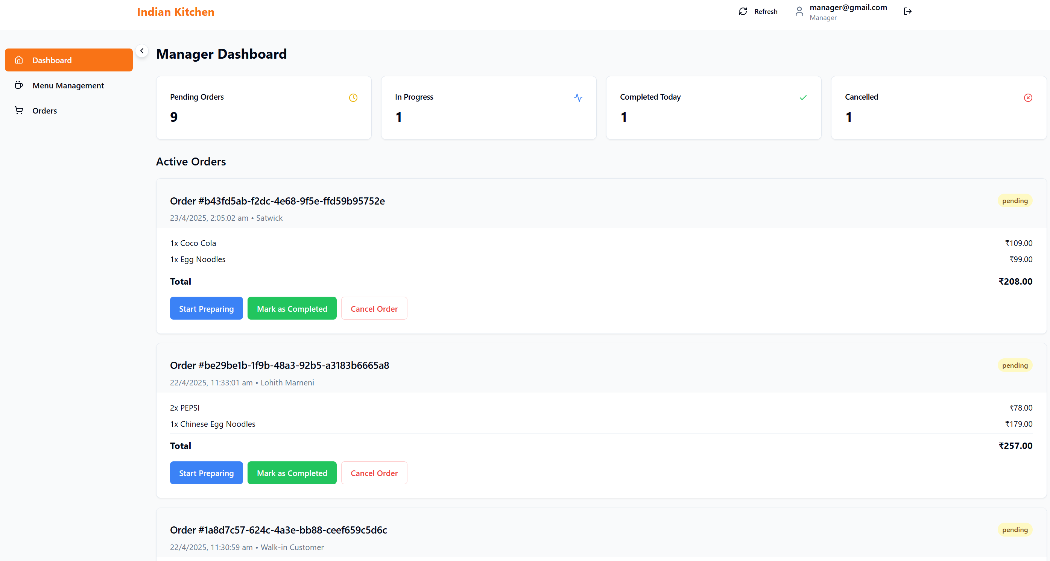

Menu Management : 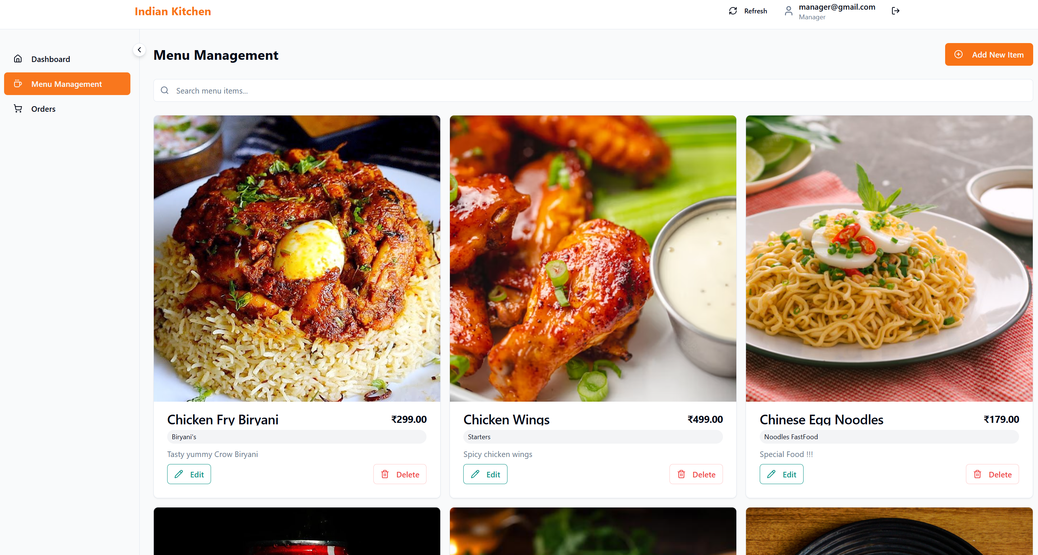

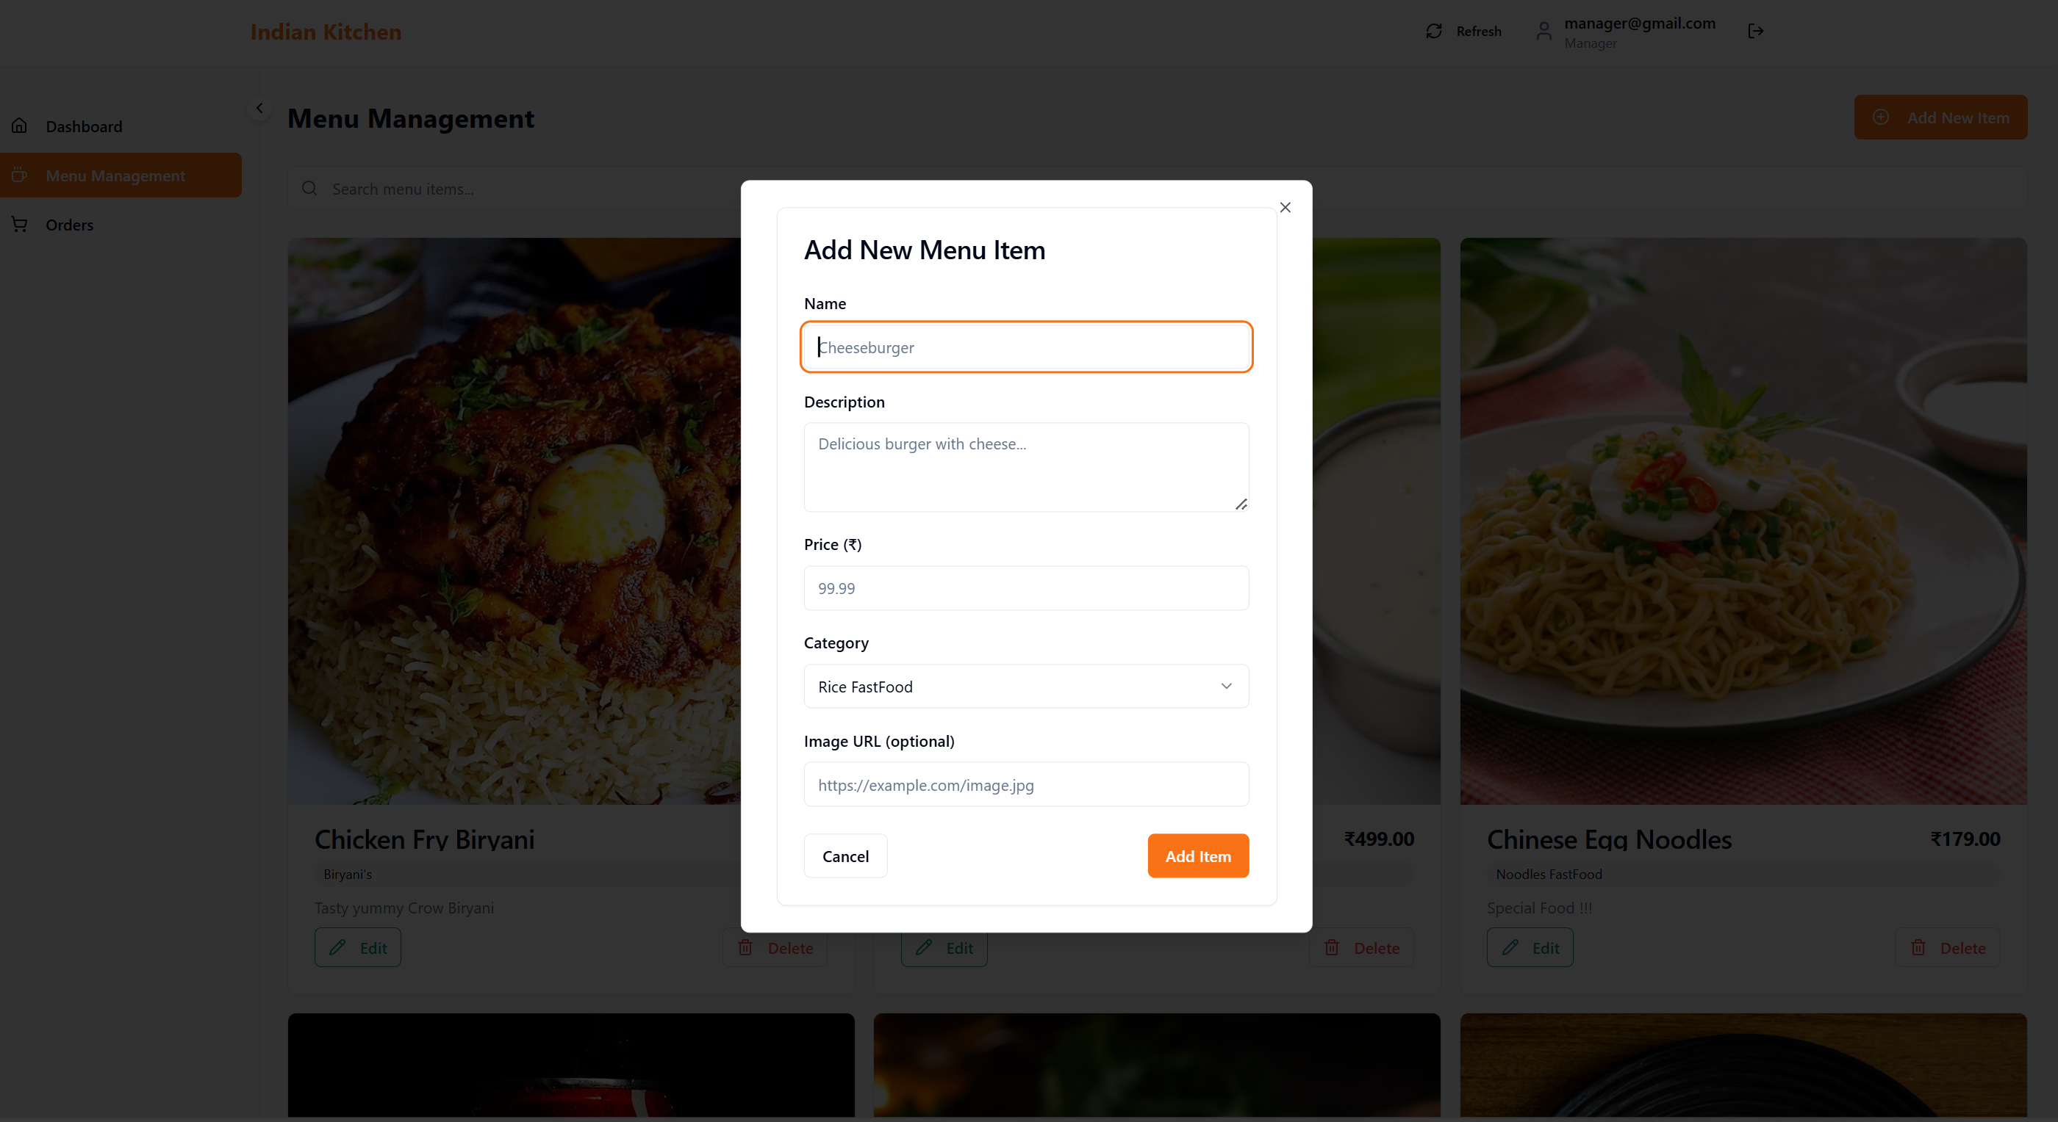

Admin DashBoard : 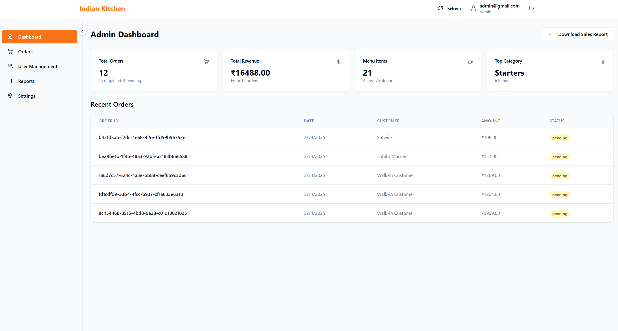

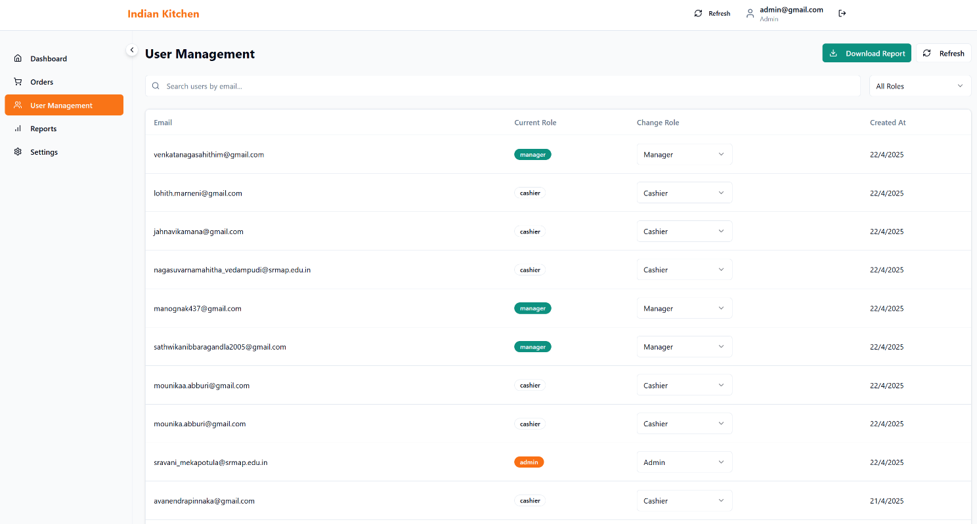

Reports :

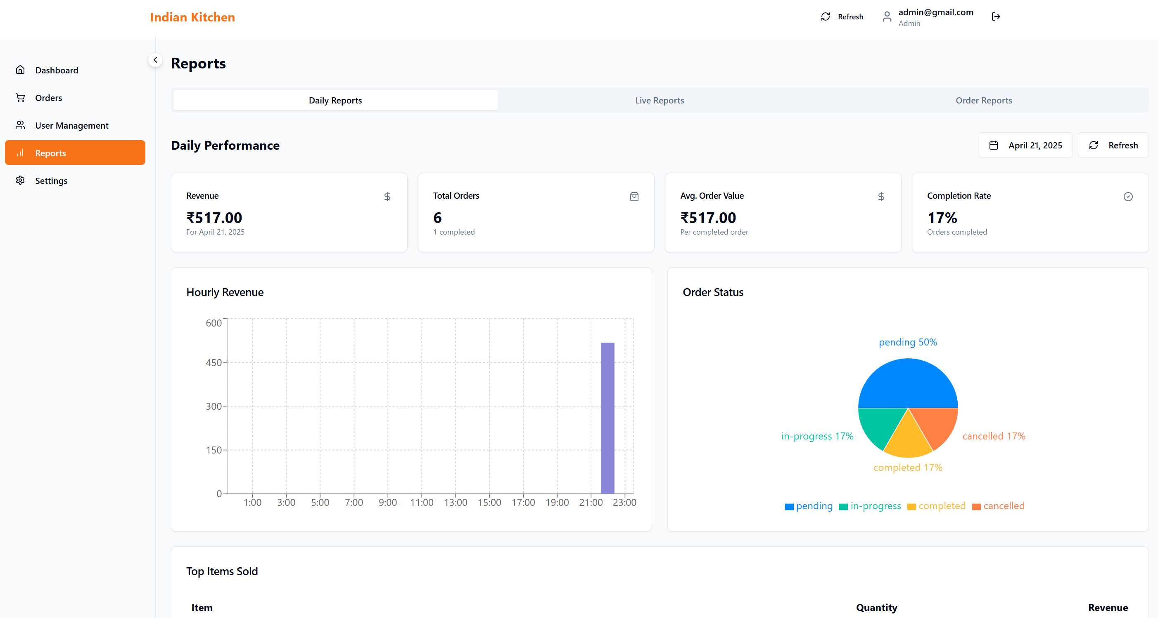

Settings Tab :

